ReactJS Hands-on 16: Registration Form Validation

Project Structure

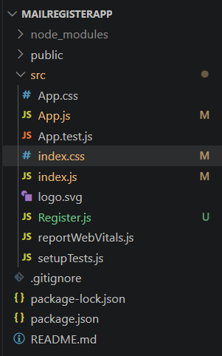

App.js
import Register from './Register';
function App() {
return <Register />;
}
export default App;

Register.js
import { useState } from 'react';
function Register() {
const [name,setName]=useState('');
const [email,setEmail]=useState('');
const [password,setPassword]=useState('');
const validate=(e)=>{
e.preventDefault();
if(name.length<5){
alert('Full Name must be at least 5 characters long!');
return;
}
const pattern=/^[^\s@]+@[^\s@]+\.[^\s@]+$/;
if(!pattern.test(email)){
alert('Email is not valid!');
return;
}
if(password.length<8){
alert('Password must be at least 8 characters long!');
return;
}
alert('Valid Form');
};
return(
<div style={{textAlign:'center'}}>
<h1 style={{color:'red'}}>Register Here!!!</h1>
<form onSubmit={validate}>
<p>
<label>Name: </label>
<input
type='text'
value={name}
onChange={(e)=>setName(e.target.value)}
/>
</p>
<p>
<label>Email: </label>
<input
type='text'
value={email}
onChange={(e)=>setEmail(e.target.value)}
/>
</p>
<p>
<label>Password: </label>
<input
type='password'
value={password}
onChange={(e)=>setPassword(e.target.value)}
/>
</p>
<button type='submit'>Submit</button>
</form>
</div>
);
}
export default Register;

index.js
import React from 'react';
import ReactDOM from 'react-dom/client';
import './index.css';
import App from './App';
const root = ReactDOM.createRoot(document.getElementById('root'));
root.render(<App />);

Validation Rules
• Name must contain at least 5 characters.
• Email must be in valid format.
• Password must contain at least 8 characters.
• If all validations pass, 'Valid Form' is displayed.

Initial Form
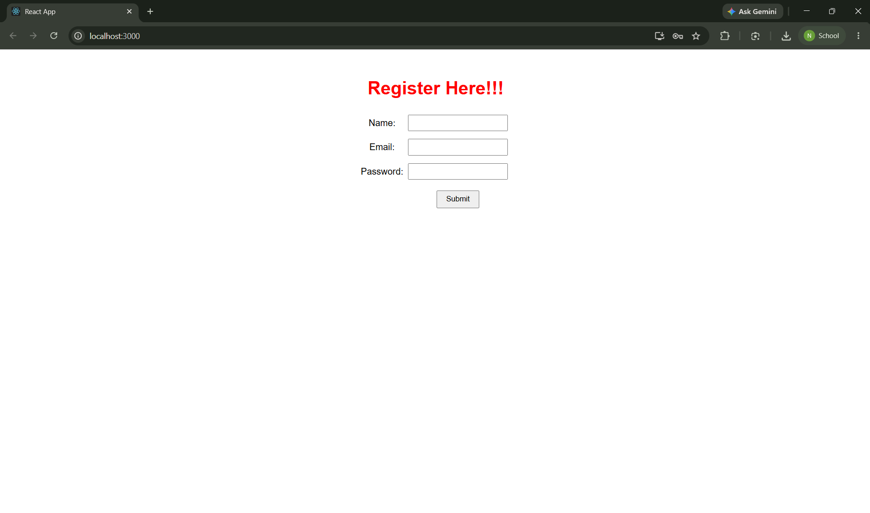

Invalid Name
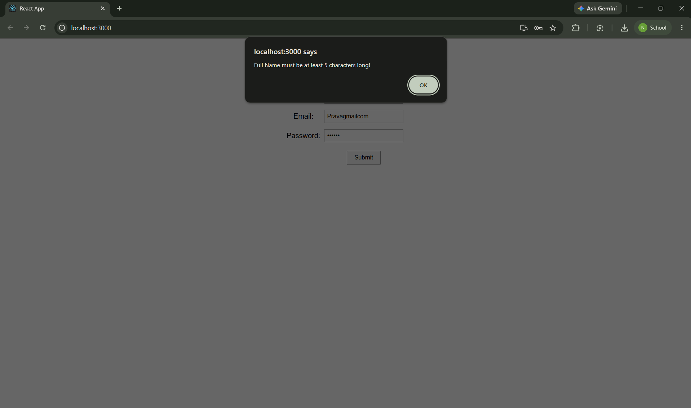

Invalid Email
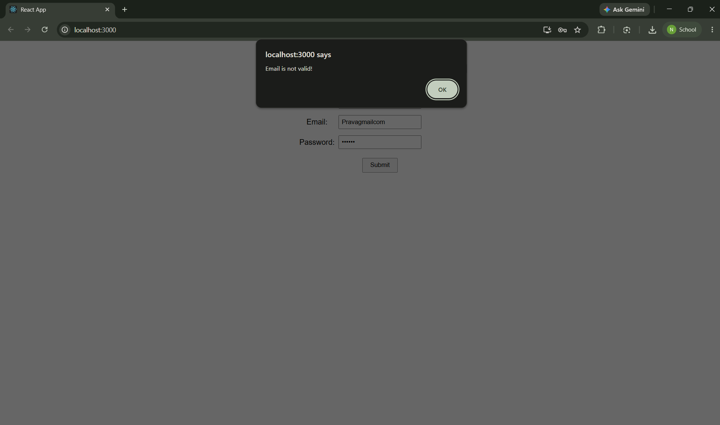

Invalid Password
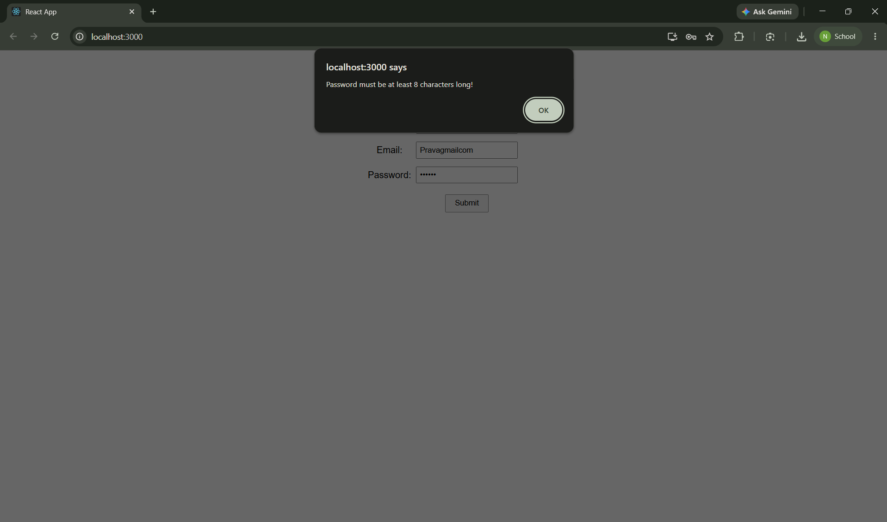

Valid Input
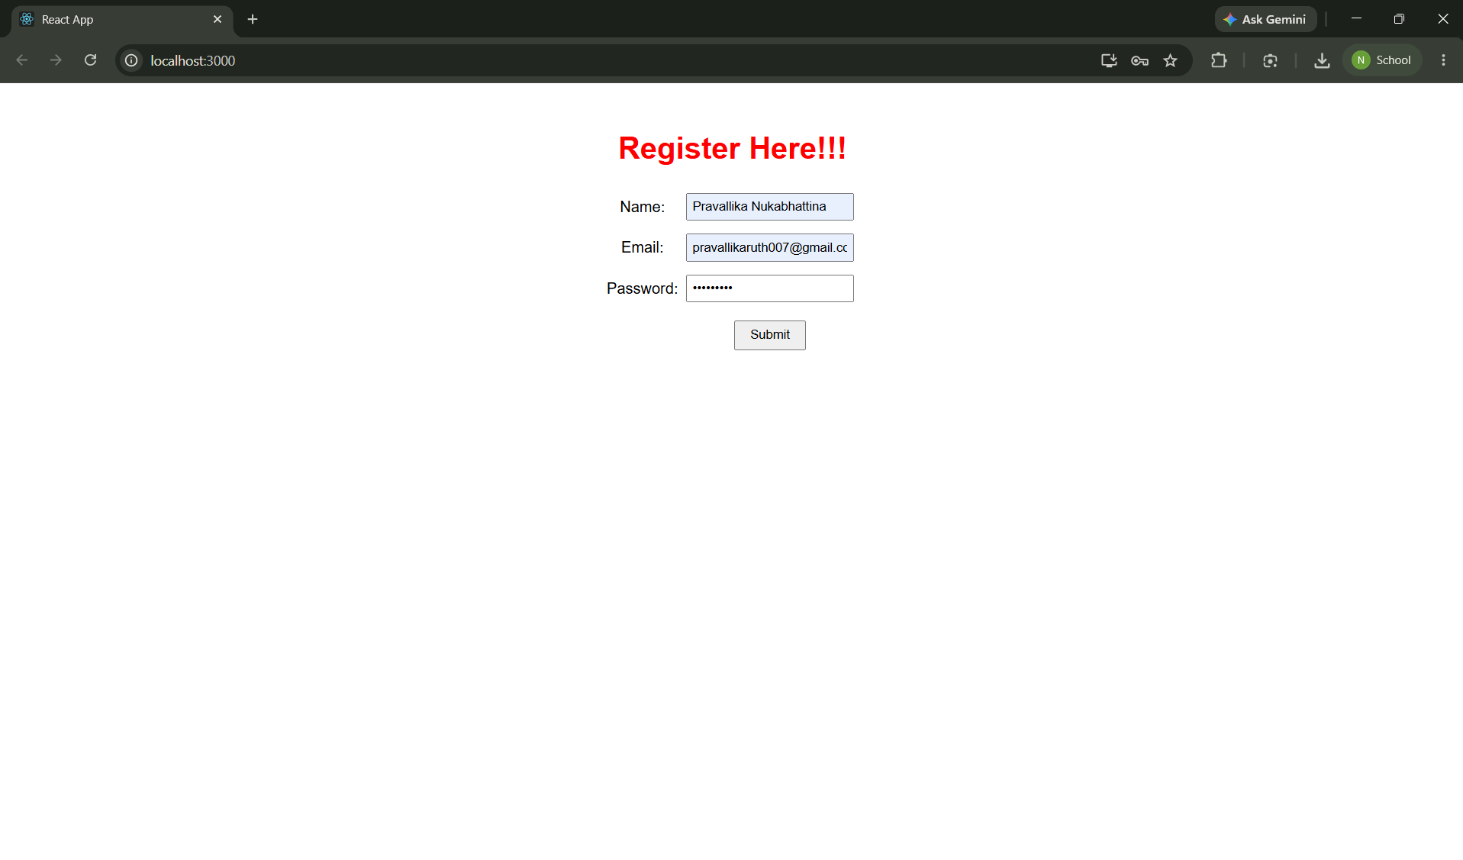

Successful Output
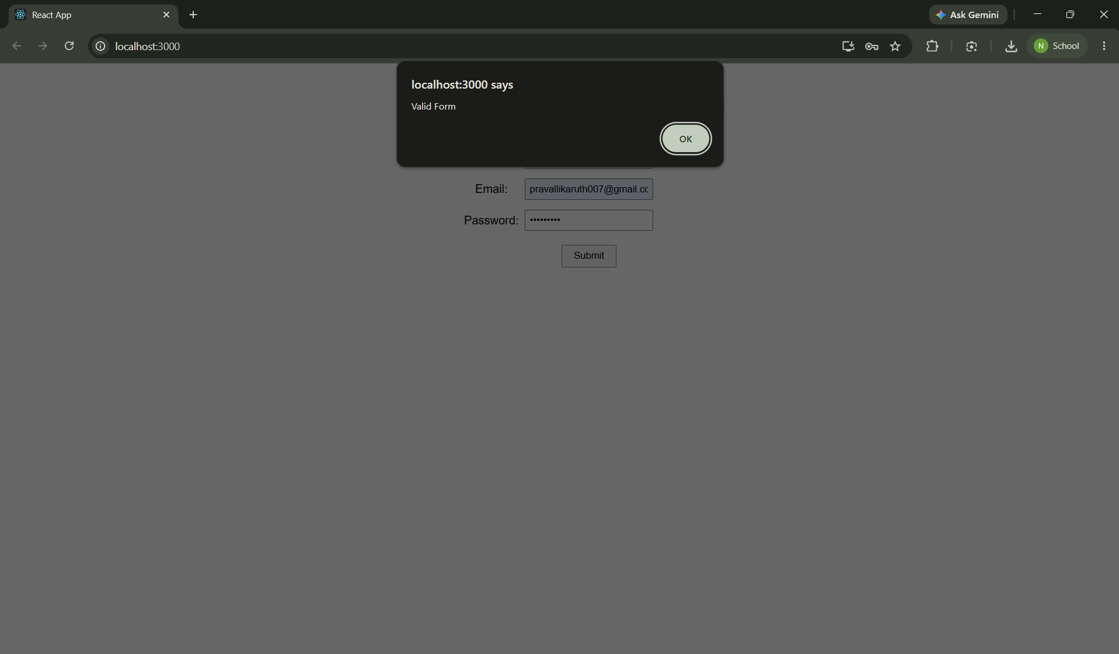

Conclusion
The registration form validates user inputs successfully and displays appropriate validation messages.

